|  |  |
| --- | --- |
| cetlogo ***CHEMICAL ENGINEERING TRANSACTIONS***  ***VOL. xxx, 2024*** | A publication of  aidiclogo_grande |
| The Italian Association  of Chemical Engineering  Online at www.cetjournal.it |
| Guest Editors: Valerio Cozzani, Bruno Fabiano, Genserik Reniers  Copyright © 2024, AIDIC Servizi S.r.l. **ISBN** 979-12-81206-11-3; **ISSN** 2283-9216 | |

Products of thermal decomposition of brominated polymer flame retardants

Monika Boruckaa\*, Kamila Mizeraa, Jan Przybysza, Agnieszka Gajeka

a Department of Chemical, Biological and Aerosol Hazards, Central Institute for Labour Protection – National Research Institute, Czerniakowska 16, 00-701 Warsaw, Poland

\* Correspondence: monika.borucka@ciop.pl

The variety of polymer materials causes they are used in packaging production, building, transport, electrical and electronics industry, agriculture, medicine and sports. Unfortunately, the main disadvantage of polymer materials is their flammability. In fire, polymeric materials pose a high risk to people, property and the environment.

Above 200 flame retardants have been designed to cover most of the requirements of the market. They are mainly based on halogen (bromine and chlorine), phosphorus, inorganic and melamine compounds. Among them, brominated flame retardants are known for their very efficient role in saving lives and goods due to their optimal combination of properties.

Fire effluent toxicity and toxic hazard in fires are highly dependent on both fire scenario and material composition. Therefore, measures of fire safety and the assessment of toxic effects of fires on humans, which are the key factors to assess fire hazards, have been researched in the last decades. However, it is more recognized that there is also a need to assess the environmental impact of toxic compounds within fire effluents. In this work, the study of asphyxiates, irritants, volatile and semi-volatile organic compounds emitted in fire effluents during thermal degradation of brominated polymer flame retardants was done. The steady-state tube furnace has been used specifically to generate toxic products from real fires under different conditions. The concentration of asphyxiates and irritants gases was determined using a gas analyser: Fourier transform infrared (FT-IR) spectroscopy. The released species have been sampling using solid phase microextraction technique (SPME) and identified using gas chromatography with mass selective detector (GC-MS). Moreover, the cone calorimetry test was used to investigate material flammability and burning behaviour of selected materials.

* 1. Introduction

Brominated flame retardants (BFRs), due to their properties of delaying combustion, have often been used as fire additives extensively used in plastic processing, electronic products, building materials and textiles (Wang et al., 2023)

Fire effluent toxicity and toxic hazard in fires are highly dependent on the both fire scenario and material composition (Stec et al., 2008). Therefore, measures of fire safety and the assessment of toxic effects of fires on humans, which are the key factors to assess fire hazards, have been researched in the last decades. However, it is more recognized that there is also a need to assess the environmental impact of toxic compounds within fire effluents. Since ecotoxicology investigates the toxic effects of fire effluents on populations, interactions between ecology and toxicology are very important. These interactions may be complex and may involve research of food chains with several different trophic levels. This makes tracing of toxicants, to obtain reliable results, a real challenge. To tackle it, the bench-scale test is a cheaper and less complex method than large-scale fire simulations (Purser et al., 2010).

The “novel” brominated flame retardants (NBFRs) are introduced to replacements for the banned chemicals (Betts, 2008). Important representatives of this group are: 1,2-bis (pentabromodiphenyl)ethane (DBDPE), ethylene bis(tetrabromo phthalimide( (EBTPI) and tetrabromobisphenol A diallyl ether (TBBPA-BAE), Fig. 1.

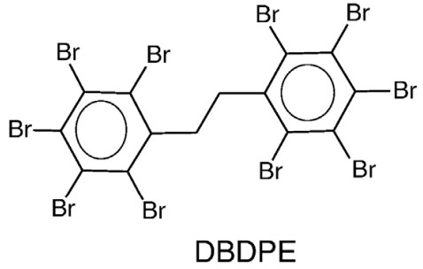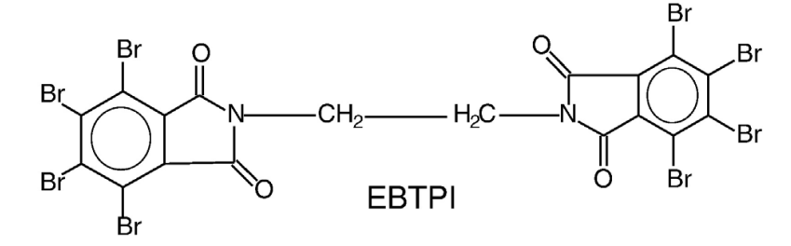

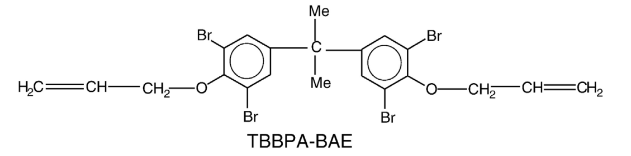

*Figure 1: Chemical structures of NBFRs: 1,2-bis (pentabromodiphenyl)ethane (DBDPE), ethylene bis(tetrabromo phthalimide) (EBTPI) and tetrabromobisphenol A diallyl ether (TBBPA-BAE).*

In this work, the study of asphyxiates, irritants volatile and semi-volatile organic compounds emitted in fire effluents during thermal degradation of brominated polymer flame retardants: 1,2-bis (pentabromodiphenyl)ethane (DBDPE), ethylene bis(tetrabromo phthalimide( (EBTPI) and tetrabromobisphenol A diallyl ether (TBBPA-BAE) were done. The steady-state tube furnace has been used specifically to generate toxic products from real fires under oxygen deficiency conditions. The concentration of asphyxiates and irritants gases was determined using a gas analyser: Fourier transform infrared (FT-IR) spectroscopy. The released species have been collected and sampled using solid phase microextraction technique (SPME) and identified by gas chromatography with mass selective detector (GC-MS). Moreover, the cone calorimetry test was used to investigate material flammability and burning behaviour of selected materials.

2. Methodology

* 1. Materials

1,2-bis (pentabromodiphenyl)ethane (DBDPE), ethylene bis(tetrabromophthalimide (EBTPI) and tetrabromobisphenol A diallyl ether (TBBPA-BAE) were purchased from Hangzhou Mei Wang Chemical Co., Ltd. in China.

* 1. **Methods**

Cone Calorimeter (CC) (Fire Testing Technologies, UK) tests were performed to investigate materials flammability and burning behavior. The test specimens (100×100×10 mm, 60 g) were placed in an aluminum tray and irradiated horizontally at a heat flux of 50 kW/m2. The procedure of the tests was performed in accordance with ISO 5660-1.

The steady-state tube furnace (Purser furnace, ISO 19700) has been used specifically to generate toxic products from real fires under oxygen deficiency conditions. The method was used to model Fire Stage 3: Less well-ventilated flaming (exactly 3a. small-vitiated fires in closed or poorly ventilated compartments ISO 19706). Temperature of heating zone of furnace was set at 650 °C. The samples of selected fire retardants (20 g) were fed into the furnace in the boat travelling at 40 mm/min.

The yields of carbon oxide (CO), hydrogen cyanide (HCN), formaldehyde (HCOH), nitrogen oxides (NOx) and light hydrocarbons were determined using a gas analyser: Fourier transform infrared (FT-IR) spectroscopy coupled with a computer system (Gasmet Portable FTIR Gas Analyzer DX4000). The samples of fire effluent were collected from the mixing chamber of the furnace using a PSP4000-H gas probe and Gasmet’s Portable Sampling System.

The volatile and semi-volatile organic compounds emitted in fire effluents during thermal degradation of brominated polymer flame retardants were taken from the mixing chamber by introducing the solid phase microextraction device with the carboxen/polydimethylsiloxane (CAR/PDMS Supelco, USA) fiber coatings. Before use, the fiber was conditioned in the injection port of gas chromatograph (GC), according to the manufacturer's instructions. After collection (5min), the solid phase microextraction technique (SPME) fiber was withdrawn from the chamber and desorbed immediately in the GC injector for analysis. The products were analysed using gas chromatograph (GC 7890 A, Agilent Technologies, USA) with mass spectrometer (MSD 5975, Agilent Technologies, USA). Chromatographic separation was achieved on a HP-5MS fused-silica capillary column (30 m × 0,25 mm × 0,25 μm film thickness) using helium as the carrier gas at 1 ml/min. The oven temperature was maintained at 40 °C for 3 min, increased by 5 °C/min to 75 °C and held for 10 minutes, then increased by 10 °C/min to 280 °C and held for 5 minutes. The GC injector port was 250 °C. The MSD was operated by electronic impact (70 eV) in scan mode (25–450 m/z). Chromatographic peaks were identified through comparing the mass ions of each peak with NIST MS Library. Based on the NIST library, the highest possibility of product identification was chosen (> 90 %). The chromatographic peak area of a specific compound is correlated linearly with its quantity, so its concentration can be reflected by the peak area ratio. The summed identified peak areas were normalized to 100% and the relative abundance of specific compound can be reflected by its peak area ratio.

1. Results
   1. Burning behavior

The burning behavior of selected flame retardants, such as ignition time (TTI), amount of smoke and heat release, as well as char formation were determined. Table 1 summarizes the results obtained from a cone calorimeter test for all series of materials. The use of brominated flame retardants resulted in non-ignition during the tests, with low values of maximum heat release rate (pHRR) and total heat release (THR). However, there was flameless decomposition accompanied by the emission of significant amounts of gases and fumes (TSR). Materials containing aromatic rings or halogens increased smoke release, while those with a high amount of oxygen or nitrogen atoms decreased smoke release. Oxygen-rich macromolecular structures are already partially oxidized, leading to a lower ability to form soot. This likely explains the lowest TSR parameter reached by the EBTEBPI flame retardant in the tests.

Table 1: Summary of cone calorimeter data

|  |  |  |  |  |
| --- | --- | --- | --- | --- |
| Flame retardant | TTI  (s) | pHRR (kW/m2) | THR  (MJ/m2) | TSR  (m2/ m2) |
| DBDPE | - | 28 (0) | 30 (2) | 3257 (43) |
| EBTEBPI | - | 26 (1) | 23 (0) | 1153 (26) |
| TBBPA-BAE | - | 28 (0) | 31 (6) | 2566 (39) |

* 1. Determination of the asphyxiates and irritants

The concentrations of asphyxiates and irritants gases released during the thermal decomposition of flame retardants are determined in Table 2. The DBDPE molecule contains the largest number of bromine atoms and during thermal degradation released the smallest yields of all monitored gases. The largest amounts of CO were released during degradation of TBBPA-BAE at 650 °C (three times higher than during pyrolysis of DBDPE).

Table 2: Yields of carbon monoxide (CO), nitrous oxide (N2O), nitrogen monoxide (NO), nitrogen dioxide (NO2), formaldehyde (CHOH) and hydrogen cyanide (HCN) released during thermal degradation of selected flame retardants at 650°C

|  |  |  |  |  |  |  |  |
| --- | --- | --- | --- | --- | --- | --- | --- |
| Flame retardant | Yields (ppm) | | | | | | |
| CO | N2O | NO | | NO2 | CHOH | HCN |
| DBDPE | 9 579 | 3,25 | | 20 | 8,67 | 0,61 | - |
| EBTEBPI | 13 522 | 35 | | 97 | - | 1,55 | 3,85 |
| TBBPA-BAE | 31 605 |  | | 84 | 31 | - | - |

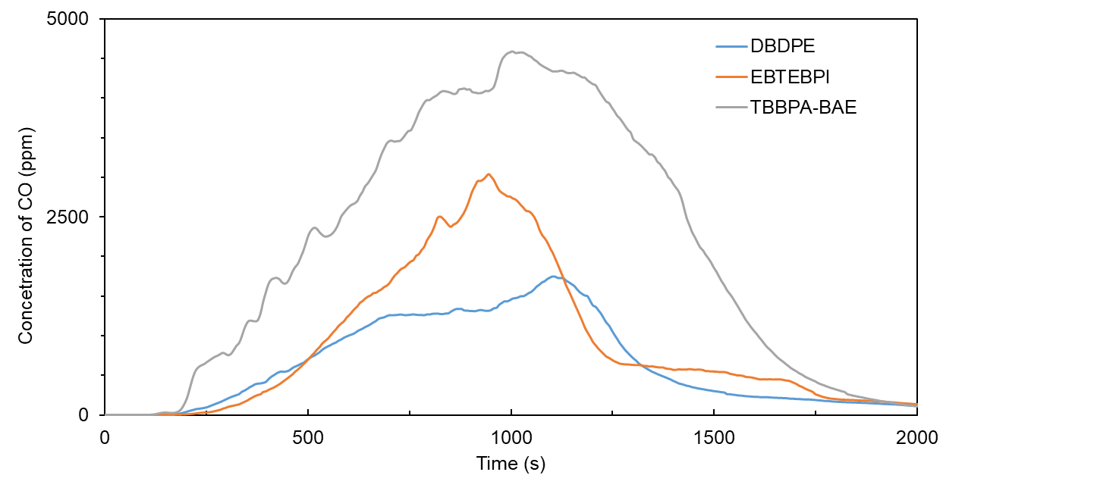

Figure 2: Comparison of yields of carbon monoxide (CO) released during thermal degradation of selected flame retardants at 650°C

During thermal degradation at 650 °C all tested flame retardants showed similar behaviour in CO emission. On rejected curves (Figure 2) there are maximum emission at about 1000 s and then the CO emission decreases.

* 1. Determination of the light hydrocarbons

The main light hydrocarbon observed in fire effluents obtained during thermal degradation of selected flame retardants are reported in Table 3. All tested materials during thermal decomposition at 650 °C released ethylene. Only in fire effluents emitted during degradation of TBBPA-BAE the significant amounts of methane presented. Moreover, the ethane and propane were also identified in degradation products of tetrabromobisphenol A diallyl ether.

Table 3: Yields of methane (CH4), ethane (C2H6), ethylene (C2H4), propane (C3H8) and hexane (C6H14) released during thermal degradation of selected flame retardants at 650°C

|  |  |  |  |  |  |
| --- | --- | --- | --- | --- | --- |
| Flame retardant | Yields (ppm) | | | | |
| CH4 | C2H6 | C2H4 | C3H8 | C6H14 |
| DBDPE | - | - | 3,08 | - | - |
| EBTEBPI | - | - | 4,18 | - | - |
| TBBPA-BAE | 1260 | 78 | 177 | 1,06 | - |

* 1. Determination of the volatile and semi-volatile products

More than 22 thermal degradation products were detected in fire effluents, unfortunately, not all of them could be identified. The main products identified in fire effluents released during thermal decomposition at 650 °C are summarized in Table 4.

During the pyrolysis of DBDPE and EBTEBPI the main identified compounds were: hydrogen bromide and bromine. Moreover, brominated hydrocarbons (both alkanes and aromatic hydrocarbons) were present in the mixture of emitted gases. TBBPA-BAE also degraded caused emissions of HBr, but the remaining products were already different than those detected during decomposition of DBDPE and EBTEBPI. The main product of thermal decomposition of TBBPA-BAE was phenol. As a corrosive substance, phenol denatures proteins and generally acts as a protoplasmic poison. Phenol may also cause peripheral nerve damage (ATSDR). During thermal degradation of tetrabromobisphenol A diallyl ether the bromophenols: 2-bromophenol, 4-bromophenol, 2,4-dibromophenol and 2,4,6-tribromophenol were also released in significant amounts. The products detected in gases and fumes emitted during the thermal decomposition of TBBPA-BAE are very similar to the products determined in studies on the decomposition of tetrabromobisphenol A itself (Altarawneh et al., 2019). It can therefore be concluded that the mechanism of decomposition of the tetrabisphenol A derivative is very similar to the mechanism of TBBPA decomposition (Borucka et al., 2024).

Table 4: List of products identified in fire effluents released during thermal decomposition of selected brominated flame retardants at 650 °C

|  | Identified thermal degradation product | CAS | Amounts (%) of identified product | | |
| --- | --- | --- | --- | --- | --- |
| DBDPE | EBTEBPI | TBBPA-BAE |
| 1 | Hydrogen bromide | 557-93-7 | 32,79 | 17,07 | 6,80 |
| 2 | Bromine | 7726-95-6 | 6,44 | 25,72 |  |
| 3 | Tribromomethane (Bromoform) | 75-25-2 | 0,19 | 0,48 |  |
| 4 | Tribromoethylene | 598-16-3 | 0,18 | 0,11 |  |
| 5 | Tetrabromomethane (Carbon tetrabromide) | 588-13-4 | 0,48 | 0,33 |  |
| 6 | 2,5-Dibromo-3,6-dimethylbenzonitrile | 38319-75-4 |  | 0,85 |  |
| 7 | Tetrabromoethylene | 79-28-7 | 1,03 | 0,32 |  |
| 8 | 1,3,5-Tribromobenzene | 626-39-1 | 0,48 | 0,63 |  |
| 9 | Phenol | 108-95-2 |  |  | 29,33 |
| 10 | Benzo[b]furan | 271-89-6 |  |  | 1,52 |
| 11 | 2-Bromophenol | 95-56-7 |  |  | 13,72 |
| 12 | 2-Methylbenzofuran | 4265-25-2 |  |  | 0,53 |
| 13 | 5-Bromo-1-benzofuran | 23145-07-5 |  |  | 3,67 |
| 14 | 4-Bromophenol | 106-41-2 |  |  | 6,90 |
| 15 | 2,4-Dibromophenol | 615-58-7 |  |  | 7,56 |
| 16 | 5-Bromo-2-methyl-1-benzofuran | 54965-04-7 |  |  | 1,11 |
| 17 | Bromohydroquinone | 583-69-7 |  |  | 2,51 |
| 18 | 2,4,6-Tribromophenol | 118-79-6 |  |  | 2,07 |
| 19 | 1,2,4,5-Tetrabromobenzene | 636-28-2 | 1,38 | 2,83 |  |
| 20 | 2,3,4,5,6-Pentabromostyrene | 53097-59-9 |  | 1,52 |  |
| 21 | 1,5-Dibromo-2,6-bis(bromomethyl)naphthalene | 85477-63-0 | 1,83 | 0,25 |  |
| 22 | 2,6-Dibromohydroquinone | 3333-25-3 |  |  | 1,06 |

1. Conclusions

The work provides valuable information on the emission of asphyxiating and irritating gases as well as volatile and semi-volatile compounds during the thermal decomposition of brominated polymer flame retardants: 1,2-bis (pentabromodiphenyl)ethane, ethylene bis(tetrabromo phthalimide) and tetrabromobisphenol A diallyl ether. The main products detected in the gases and fumes emitted during the thermal decomposition of flame retardants were: carbon oxide and hydrogen bromide. Additionally, 1,2-bis(pentabromodiphenyl)ethane and ethylene bis(tetrabromo phthalimide) released brominated hydrocarbons, while tetrabromobisphenol A diallyl ether decomposed into phenol and bromophenols. These findings underscore that while flame retardant substances serve their intended purpose, they also emit hazardous substances that can pose a threat to people and the environment.

Acknowledgments

This paper was created on the basis of results of a research task carried out within the scope of the 6th stage of the National Programme “Governmental Programme for Improvement of Safety and Working Conditions”, funded by state services of the Ministry of Family, Labour and Social Policy (under the name of the Ministry of Family and Social Policy prior to December 12th, 2023). Task no. 3.ZS.09 entitled “Analysis of pollutants produced during the combustion of plastics containing flame retardant additives”. The Central Institute for Labour Protection – National Research Institute is the Programme’s main co-ordinator.

References

ATSDR, Agency for Toxic Substances and Disease Registry < <https://wwwn.cdc.gov/TSP/MMG/MMGDetails.aspx?mmgid=144&toxid=27#bookmark02>accessed> 14.02.2024.

Altarawneh M., Saeed A., Al-Harahsheh M., Dlugogorski B.Z., 2019, Thermal decomposition of brominated flame retardants (BFRs): Products and mechanisms, Progress in Energy and Combustion Science, 70, 212-259

Betts K., 2008, New flame retardants detected in indoor and outdoor environments, Environ, Sci Technol, 42, 6778.

Borucka M., Mizera K., Przybysz J., Gajek A., 2024, Products of decomposition and combustion of bromine flame-retardant - tetrabromobisphenol A bis (diallyl ether), Przemysl Chemiczny, in press.

ISO 5660-1, 2015, Reaction-to-fire tests — Heat release, smoke production and mass loss rate — Part 1: Heat release rate (cone calorimeter method) and smoke production rate (dynamic measurement).

ISO 19700, 2016, Controlled equivalence ratio method for the determination of hazardous components of fire effluents — Steady-state tube furnace.

ISO 19706, 2011, Guidelines for assessing the fire threat to people.

Purser D.A., Stec A.A., Hull T.R., 2010, Fire scenarios and combustion conditions, In: Stec A.and Hull R. (Ed.), Fire toxicity, Cambridge Woodhead Publishing, 26-47.

Stec A.A., Hull T.R., Lebek K., Purser J.A., Purser D.A., 2008, The effect of temperature and ventilation condition on the toxic product yields from burning polymers, Fire and Materials, 32, 49-60.

Wang N., Lai C., Xu F., Huang D., Zhang M., Zhou X., Xu M., Li Y., Li L., Liu S., Huang X., Nie J., Li H., 2023, A review of polybrominated diphenyl ethers and novel brominated flame retardants in Chinese aquatic environment: Source, occurrence, distribution, and ecological risk assessment, Science of The Total Environment, 904, 166180.